R&D REPORT

TITLE : HANDLING WITH SEPARATE CHAINING USING
LINKED LIST
Done by GEERTHANA . K ,
BSC IT, KPRCAS

Abstract:
Hashing is an efficient technique used for fast data storage and retrieval. When two keys map to the same index, collisions occur. This R&D explores the concept of hashing and explains separate chaining, a collision-handling method that uses linked lists to store multiple values in the same bucket. Simple algorithms and java pseudocode are provided to help beginners understand how separate chaining works and why it is effective for managing collision.
------------------------------------------------------------------------------------------------
- Introduction
- Hashing is a fast technique used to store and retrieve data efficiently.
- It uses a Hash function to convert a key into an index of a hash table.
- Sometimes two keys may map to the same index, which is called a collision.
- One common way to handle collisions is separate chaining, where each index stores a small linked list of values.
- This method uses concepts from linear linked lists to manage multiple elements in the same hash position.

2.Hashing
Hashing is a technique used to store and retrieve data in constant time on average. Instead of searching linearly (slow), hashing uses a hash function to compute an index where data should be stored.
Indexing[i]
Hashing function
Keys

Example:
➤ Key = 27
➤ Hash function: index = key % 5
Key%5=27%5

Index=2
27

Why index = 2 ?
Because
27 ÷ 5 = 5 remainder 2
So the hash function returns 2.
3.Hash Table
A Hash table is an array where each index stores data based on the output of the hash function.
Index | Bucket
0 | 0
1 | 0
2 | 27
3 | 0

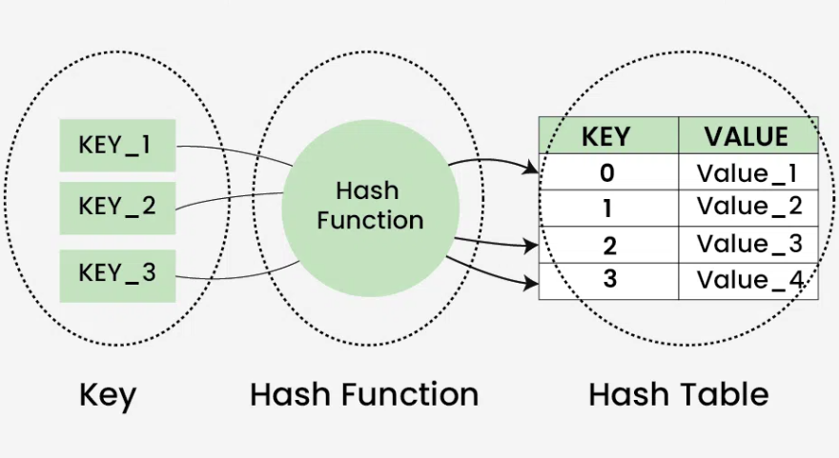
4.Collision
- A collision occurs when two different keys are mapped to the same index by the hash function.
- Since a hash table stores only one entry at each index, collisions must be handled properly to avoid overwriting existing data.

Example:

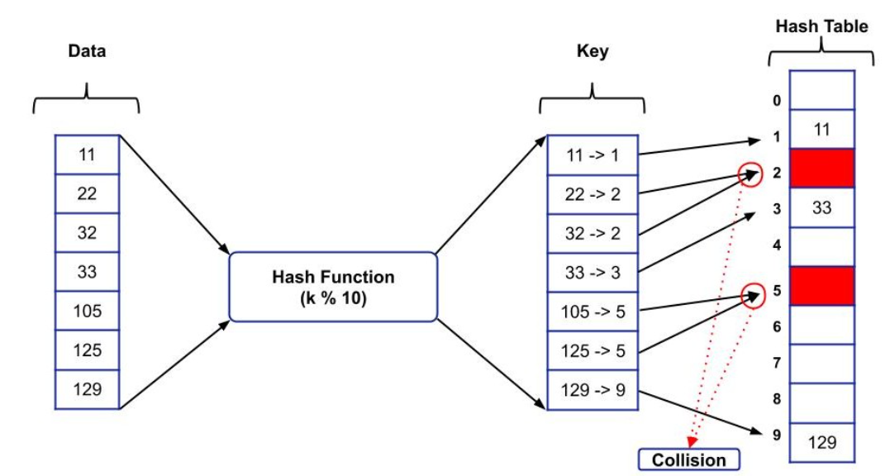

- The keys 22 and 32 want to go into index 2 at the same time the key 105 and 125 want to go to index 5, so a collision happens.
- Without a collision-handling method, one value would replace the other, and data would be lost.
4. Separate Chaining (Collision Handling)
- Separate Chaining means each index (bucket) of the hash table stores a linked list instead of a single value.
- If multiple keys map to the same index, they are simply added to the linked list at that index.

Why Linked List?
- It can grow dynamically
- No risk of overflow
- Easy to insert new elements
- You can traverse all values in that bucket
Example:
the table size = 5
Keys: 12, 22, 32
Hash function: index = key % 5
Keys | Hash function | Index
12 | 12 % 5 = 2 | 2
22 | 22 % 5 = 2 | 2
32 | 32 % 5 = 2 | 2

All collide at index 2.
Index | Bucket (Linked List)
0 | 0
1 | 0
2 | 12 → 22 →32
3 | 0
4 | 0
- All values that hash to index 2 are chained using a linked list.
- No data is lost, and insertion is simple.

5. Algorithm (Separate Chaining)
- Algorithm for Insertion
Input: key
Output: key inserted into correct bucket

- Compute index = key % table_size
- Go to the linked list at that index
- Create a new node with the key
- Insert the new node at the end (or beginning) of the linked list
- Stop

- Algorithm for Searching
Input: key
Output: “Found” or “Not Found”
- Compute index = key % table_size
- Go to the linked list at that index
- Traverse the list node by node
- If any node contains the key → return “Found”
- If list ends → return “Not Found”

- Algorithm for Deletion
- Compute index = key % table_size
- Go to the linked list at that index
- Traverse nodes until key is found
- Adjust the previous node’s pointer to skip the deleted node
- Free/remove the node
- Stop

- Java Pseudocode

- Node Structure

class Node

{

int data;

Node next;

}

- Hash Table Structure

class HashTable

{

Node[] table; // array of linked lists

int size;

HashTable(int size)

{

this.size = size;

table = new Node[size];

}

}

- Insert(key)

int index = key % size;

Node newNode = new Node();

newNode.data = key;

if (table[index] == null)

{

table[index] = newNode; // first node

}

else

{

Node temp = table[index];

while (temp.next != null)

{

temp = temp.next;

}

temp.next = newNode; // add at end

}

- Search(key)

int index = key % size;
Node temp = table[index];

while (temp != null)
{
if (temp.data == key)
return "Found";
temp = temp.next;
}
return "Not Found";

- Delete(key)
int index = key % size;
Node curr = table[index];
Node prev = null;
while (curr != null)
{
if (curr.data == key)
{
if (prev == null)
table[index] = curr.next; // delete first node
else
prev.next = curr.next; // bypass node
return "Deleted";
}
prev = curr;
curr = curr.next;
}
return "Key Not Found";
7. Advantages
• Handles collisions efficiently
• No overflow since linked list grows dynamically
• Simple insertion and deletion
• Works well when load factor is high
8. Disadvantages
• Extra memory needed for linked list nodes
• Searching may become slow if too many keys land in the same bucket
• Worst-case search becomes O(n)
9. Applications of Hashing
• Database indexing
• Compilers (symbol tables)
• Password storage
• Caches and lookup tables
• File systems
• Routing tables in networks
10. Conclusion
- Separate chaining is an effective method to handle collisions in hashing.
- By combining a hash table with linked lists, it maintains fast insertion and search while avoiding data loss.
- This makes hashing a powerful tool for real-time applications requiring quick access.

References
Web References
- GeeksforGeeks. Hashing | Separate Chaining. Available at:
https://www.geeksforgeeks.org/separate-chaining-collision-handling-technique-in-hashing/
- TutorialsPoint. Hashing Techniques in Data Structures.
https://www.tutorialspoint.com/data_structures_algorithms/hash_data_structure.htm
- JavaTpoint. Hashing in Data Structure.
https://www.javatpoint.com/hashing-in-data-structure
Research Paper Reference
- Naghibzadeh, M., & Naghibzadeh, B.
"Linked List Elimination from Hashing Methods."
Ferdowsi University of Mashhad & Monash University.

